

Digital Egypt Pioneers Initiative - Data Analysis Track
EnterpriseE-Commerce Intelligence & Predictive Analytics
GRADUATION PROJECT DOCUMENTATION
2025 / 2026
Alia Amir Ali
Esraa Abu Bakr
Manar Magdy
Maha Saleh
Menna Mohamed
Rofyda Sayed

Supervisor: Eng. Mohamed Alemam

Chapter 1
Project Overview

1 Project Overview
The rapid growth of the global gaming industry has transformed video gaming from a niche hobby into one of the most widespread recreational activities in the world. As gaming becomes increasingly integrated into daily life, understanding its relationship with mental health, sleep quality, physical well-being, and productivity has become a critical area of inquiry for researchers, health professionals, and policymakers alike.

1.1 Project Concept
This project - Gaming & Mental Health - is a graduation project developed as part of the Digital Egypt Pioneers Initiative (DEPI), Data Analysis Track. The project leverages a large-scale, synthetically generated dataset sourced from Kaggle to explore how gaming habits, behaviors, and platform usage patterns correlate with a wide range of mental and physical health indicators across a diverse population of gamers.
The analysis pipeline was built entirely on Microsoft Fabric, following the Medallion Architecture (Bronze - Silver - Gold), and culminates in an interactive Power BI dashboard designed to surface actionable insights for researchers and the general public alike.
The motivation behind this project is twofold:
- Analytical: To apply the full data analysis pipeline - from raw ingestion and cleaning to dimensional modeling and interactive visualization - to a real-world, socially meaningful domain.
- Social: To produce insights that highlight which gaming behaviors pose the highest mental and physical health risks, and which population segments are most vulnerable - information that could inform future awareness campaigns or intervention strategies.

Project objectives span five domains:
- Data Engineering: Ingest, validate, and clean a 1-million-row gaming and mental health dataset using Microsoft Fabric and PySpark across the Medallion Architecture layers.
- Feature Engineering: Derive meaningful composite KPIs - including a Mental Health Risk Index, Gaming Impact Score, and Balanced Gamer Score - that go beyond raw survey fields to capture nuanced behavioral patterns.
- Dimensional Modeling: Design and populate a star-schema data model in the Gold layer, consisting of a central fact table and five dimension tables optimized for Power BI consumption.
- Dashboard Development: Build a five-page interactive Power BI dashboard covering Executive Overview, Gaming Behavior, Mental Health, Sleep & Physical Health, and Productivity & Academic Impact.
- Insight Generation: Identify statistically meaningful correlations between gaming habits and health outcomes, and communicate them clearly through data storytelling.

1.2 Data Source
The dataset used in this project is the Gaming and Mental Health Dataset, published on Kaggle by the user sharmajicoder. It is a large-scale synthetic dataset generated to simulate realistic survey-based data capturing the gaming habits and health profiles of a global population of gamers.

Attribute | Detail
Dataset Name | Gaming and Mental Health Dataset
Source Platform | Kaggle
Publisher | sharmajicoder
Dataset URL | kaggle.com/datasets/sharmajicoder/gaming-and-mental-health
Data Type | Synthetic / Simulated Survey Data
Total Rows Available | ~1,000,000 records
Rows Used in Project | 1,000,000 records (full downloaded subset)
File Format | CSV (converted to Parquet for processing)
License | Open / Public (Kaggle)

The dataset contains 39 raw columns spanning five thematic domains: demographics, gaming behavior, mental health indicators, physical health indicators, and social/productivity metrics.

Column Name | Type | Description
age | Integer | Age of the respondent in years
gender | String | Gender identity (Male / Female / Non-binary / Other)
income | Float | Reported annual household income (USD)
daily_gaming_hours | Float | Average number of hours spent gaming per day
weekly_sessions | Integer | Number of distinct gaming sessions per week
weekend_gaming_hours | Float | Gaming hours specifically on weekends
years_gaming | Integer | Total years the respondent has been gaming
esports_interest | String | Level of interest in esports (High / Medium / Low / None)
competitive_rank | String | Self-reported competitive rank in online games
streaming_hours | Float | Weekly hours spent watching game streams
mobile_gaming_ratio | Float | Proportion of gaming done on mobile (0-1)
multiplayer_ratio | Float | Proportion of gaming in multiplayer mode (0-1)
violent_games_ratio | Float | Proportion of time spent on violent game titles (0-1)
night_gaming_ratio | Float | Proportion of gaming sessions that occur at night (01)
microtransactions_spending | Float | Monthly spending on in-game microtransactions (USD)
screen_time_total | Float | Total daily screen time across all devices (hours)
headset_usage | String | Frequency of headset usage during gaming sessions
internet_quality | String | Self-reported internet connection quality
Column Name | Type | Description
sleep_hours | Float | Average nightly sleep duration (hours)
exercise_hours | Float | Weekly hours of physical exercise
bmi | Float | Body Mass Index of the respondent
caffeine_intake | Float | Daily caffeine intake (mg)
eye_strain_score | Float | Self-reported eye strain severity (1-10)
back_pain_score | Float | Self-reported back pain severity (1-10)
stress_level | Float | Self-reported stress level (1-10)
anxiety_score | Float | Validated anxiety scale score (1-10)
depression_score | Float | Validated depression scale score (1-10)
loneliness_score | Float | Self-reported loneliness score (1-10)
aggression_score | Float | Behavioral aggression indicator (1-10)
happiness_score | Float | Self-reported happiness / life satisfaction (1-10)
addiction_level | Float | Gaming addiction severity score (1-5)
toxic_exposure | Float | Frequency of exposure to toxic behavior online (1-10)
social_interaction_score | Float | Quality of real-world social interactions (1-10)
relationship_satisfaction | Float | Satisfaction with personal relationships (1-10)
friends_gaming_count | Integer | Number of friends who also play video games
online_friends | Integer | Number of online-only gaming friends
parental_supervision | String | Level of parental oversight of gaming (for minors)
academic_performance | Float | Self-reported academic performance score (1-10)
work_productivity | Float | Self-reported work productivity score (1-10)

1.3 Project Impact (KPIs)
The project produces a set of engineered Key Performance Indicators that go beyond the raw dataset fields. These KPIs are derived through feature engineering in the Silver layer and consumed in the Power BI dashboard.

Gaming Behavior KPIs
KPI | Definition | Derivation / Threshold
Avg Gaming Hours | Average daily gaming hours across all users. | Mean of daily_gaming_hours column
High Gaming % | Percentage of users gaming more than 5 hours/day. | Users with  daily_gaming_hours > 5 / total users
KPI | Definition | Derivation / Threshold
Night Gamers % | Percentage of gaming sessions that occur at night. | Mean of night_gaming_ratio x 100
Avg Weekly Sessions | Average number of gaming sessions per week. | Mean of weekly_sessions column
Addiction Category | Segmentation into Low, Moderate, and High addiction tiers. | Derived from addiction_level score thresholds

Mental Health KPIs
KPI | Definition | Derivation / Threshold
Mental Risk Index | Composite Z-score combining stress, anxiety, depression, and loneliness. | Z-score average of stress_level, anxiety_score, depression_score, loneliness_score
Risk Level | Categorical segmentation into Low, Moderate, or High risk. | Low: <= -0.5 | Moderate: -  0.5 to 0.5 | High: > 0.5
High Risk % | Percentage of users classified as High Risk. | High Risk count / total users x 100
Avg Depression | Mean depression score across the population. | Mean of depression_score
High Depression % | Percentage of users above the critical depression threshold (> 7/10). | Users with  depression_score > 7 / total users
Happiness Score | Population average of the self-reported happiness metric. | Mean of happiness_score
Balanced Gamer Score | Users who simultaneously meet all four healthy lifestyle thresholds. | <=4 hrs gaming/day AND >=7 hrs sleep AND >=1 hr exercise AND social score > 5

Sleep & Physical Health KPIs
KPI | Definition | Derivation / Threshold
Avg Sleep Hours | Mean nightly sleep duration across all users. | Mean of sleep_hours  (negative values corrected to 0)
Sleep Deprivation % | Percentage of users sleeping below 6 hours per night. | Users with sleep_hours < 6 / total users
Avg Exercise Hours | Mean weekly physical exercise duration. | Mean of exercise_hours
Digital Strain Index | Composite eye + back pain score normalized to 01. | Mean of (eye_strain_score + back_pain_score) / 20
Avg BMI | Population average Body Mass Index. | Mean of bmi column
KPI | Definition | Derivation / Threshold
Sleep Category | Categorization of users by sleep quality. | Derived from sleep_hours thresholds

Productivity & Academic Impact KPIs
KPI | Definition | Derivation / Threshold
Gaming Impact Score | Executive composite metric (0-100) measuring the overall negative life impact of gaming. | Normalized combination of daily_gaming_hours, sleep_hours (inverted), work_productivity (inverted), and  mental_health_risk_index
Impact Category | Segmentation into Low, Moderate, and High gaming impact tiers. | Low: 0-30 | Moderate: 31-60 | High: 61-100
Academic  Performance | Population mean academic performance score. | Mean of academic_performance
Work Productivity | Population mean work productivity score. | Mean of work_productivity
Productivity Risk | Composite flag for users with simultaneously low performance and high gaming. | Derived composite from productivity and gaming thresholds

1.4 Main Charts Overview
The five-page Power BI dashboard is structured as a data storytelling journey - beginning with a high-level executive overview and progressively drilling into root causes and consequences.

Pa  ge | Title | Focus Area | Key KPIs Shown
1 | Executive Overview | High-level project snapshot | Avg Gaming Hours, High Risk %, Mental Risk Index, Gaming Impact Score
2 | Gaming Behavior Analysis | Gaming habits & behavioral patterns | Avg Gaming Hours, High Gaming %, Night Gamers %, Avg Weekly Sessions
3 | Mental Health Analysis | Psychological impact of gaming | Mental Risk Index, Avg Depression, High  Depression %, Happiness Score, Balanced Gamer Score
4 | Sleep & Physical Health | Physical consequences of gaming | Avg Sleep Hours, Sleep Deprivation %, Avg Exercise, Digital Strain Index, Avg BMI
5 | Productivity &  Academic | Performance and output impact | Academic Performance, Work Productivity, Productivity Risk

1.5 SMART Questions
The analysis is guided by five SMART (Specific, Measurable, Achievable, Relevant, Timebound) research questions derived from the dataset structure and project objectives:

# | SMART Question | KPI / Measure
1 | Does average daily gaming hours exceed 4 hours across the population, and does this correlate with elevated mental health risk scores? | Avg Gaming Hours, Mental Risk Index
2 | What percentage of users show simultaneously elevated addiction, depression, and sleep deprivation - and does this cluster vary by age or gender? | High Risk %, Avg Depression, Sleep Deprivation %
3 | Is there a measurable difference in academic performance and work productivity between users gaming more than 5 hours/day versus those gaming fewer than 2 hours/day? | Academic Performance, Work Productivity, High Gaming %
4 | What proportion of users qualify as Balanced Gamers, and which demographic group has the highest balanced gamer rate? | Balanced Gamer Score, Night Gamers %
5 | Does the Digital Strain Index increase proportionally with total screen time, and is this effect stronger in night gamers than daytime gamers? | Digital Strain Index, Night  Gamers %

Chapter 2 Technical Architecture

2 Technical Architecture
This chapter documents the tools, architectural patterns, and data model that form the technical backbone of the project. The pipeline was built entirely on Microsoft Fabric, following the Medallion Architecture, and outputs a star-schema dimensional model consumed by Power BI.

2.1 Tools Used
Three primary platforms were used across the full pipeline - from raw data ingestion and transformation, through dimensional modeling, to dashboard design and delivery:

Tool / Platform | Role in Project | Key Usage
Microsoft Fabric | Cloud-based data engineering & lakehouse platform | End-to-end data pipeline: ingesting the raw CSV from  Kaggle, running PySpark notebooks across the Bronze, Silver, and Gold Medallion layers, and storing Delta tables consumed by Power BI.
Power BI | Business intelligence & interactive dashboard | Consumed the Gold layer Delta tables to build the five-page "Gaming Behavior & Health Impact Dashboard," including all KPI cards, charts, scatter plots, matrices, and slicers.
Figma | UI/UX design & dashboard wireframing | Used to design and prototype the dashboard layout, color scheme, page structure, and visual hierarchy before implementation in Power BI, ensuring a cohesive and polished end result.

Microsoft Fabric is a unified, cloud-based analytics platform combining data engineering, data integration, data science, and business intelligence in a single SaaS environment. Fabric served as the backbone of the entire pipeline - the raw dataset was downloaded from Kaggle using the kagglehub library, converted to PySpark, and saved to the Bronze layer. Silver and Gold transformations ran on Fabric managed Spark compute, with outputs written as Delta tables for direct Power BI connectivity.

Power BI is Microsoft industry-leading business intelligence platform, used here as the final presentation layer connecting directly to the Gold layer Delta tables via the native FabricPower BI integration. The dashboard was built across five thematic pages with KPI cards, bar charts, scatter plots, line charts, tree maps, and matrix visuals, all tied together with interactive slicers.

Figma was used during the dashboard design phase to plan layout, page structure, visual hierarchy, and color palette before a single visual was placed in Power BI. This design-first approach allowed the team to align on the storytelling flow and significantly reduce iteration time during Power BI development.

2.2 Architecture (Medallion)
The Medallion Architecture organizes data into three logical layers - Bronze, Silver, and Gold
- each serving a specific purpose. This architecture ensures raw data is never overwritten (Bronze), all cleaning logic is centralized (Silver), and the analytical layer (Gold) is purposebuilt for Power BI performance.

Bronze Layer  Raw ingestion  CSV - Parquet  No transformation Files/Bronze/ | Silver Layer  Data cleaning  Feature engineering  KPI derivation Files/Silver/ | Gold Layer  Star schema  5 dim + 1 fact Delta format  Tables/Gold/

2.3 Data Model (Star Schema)
The Gold layer implements a star schema consisting of one central Fact Table surrounded by five Dimension Tables, each connected via the User_ID surrogate key. All tables are saved in Delta format for ACID compliance and direct Power BI connectivity.

Table | Type | Key Columns | Description
fact_gaming_metrics | Fact | fact_id, User_ID, all FK keys | Central table: all quantitative metrics - gaming, mental health, physical health, productivity KPIs
dim_demographics | Dimension | dim_demo_id, User_ID | User age, gender, income
dim_health | Dimension | dim_health_id, User_ID | Sleep, exercise, BMI, stress,  Risk_Level, is_balanced_gamer
dim_gaming | Dimension | dim_gaming_id, User_ID | Gaming behavior ratios, rank, experience, headset, internet quality
dim_social | Dimension | dim_social_id, User_ID | Social interaction score, relationship satisfaction, friend counts
dim_impact | Dimension | dim_impact_id, User_ID | Engineered impact_category (Low / Moderate / High)

Chapter 3
Data Engineering

3 Data Engineering
This chapter documents the complete data preparation and transformation pipeline across the three Medallion Architecture layers, implemented on Microsoft Fabric using PySpark notebooks.

3.1 Cleaning Process
The cleaning process spans the Bronze and Silver layers. Bronze ingests and preserves raw data; Silver applies all corrections and validations.

Bronze Layer - Raw Ingestion
GitHub: Bronze_Layer.ipynb

The Bronze layer ingests raw data from Kaggle and persists it in Parquet format without any transformations, ensuring a permanent unmodified archive.

Source: Bronze_Layer.ipynb
# Import kagglehub and download the dataset import subprocess subprocess.run(["pip", "install", "kagglehub", "--quiet"])
import kagglehub, pandas as pd, numpy as np, plotly.express as px, os

path = kagglehub.dataset_download("sharmajicoder/gaming-and-mental-health") csv_file = [f for f in os.listdir(path) if f.endswith(".csv")][0] df = pd.read_csv(os.path.join(path, csv_file))

Source: Bronze_Layer.ipynb
# Convert to PySpark and save as Parquet to Bronze layer spark_df = spark.createDataFrame(df)
spark_df.write.mode("overwrite").format("parquet").save("Files/Bronze/Gaming_Br onze")

During initial exploration, df.info() confirmed no null values across all 39 columns. df.describe() revealed three anomalies: negative sleep_hours, daily_gaming_hours exceeding 18 hours, and weekend_gaming_hours exceeding 36 hours.

Silver Layer - Data Cleaning
GitHub: Silver_Layer.ipynb

Three targeted cleaning operations were applied. No rows were dropped - all corrections preserve the full 1,000,000-row dataset.

Source: Silver_Layer.ipynb
# Read Bronze Parquet into PySpark
df = spark.read.parquet("Files/Bronze/Gaming_Bronze")

# 1. Replace negative sleep_hours with 0 (physical minimum) df = df.withColumn("sleep_hours",
F.when(F.col("sleep_hours") < 0, 0).otherwise(F.col("sleep_hours")))

# 2. Cap daily_gaming_hours at 18 hours (practical daily maximum) df = df.withColumn("daily_gaming_hours",
F.when(F.col("daily_gaming_hours") > 18, 18).otherwise(F.col("daily_gaming_hours")))

# 3. Cap weekend_gaming_hours at 36 hours (2 days x 18 hours)
df = df.withColumn("weekend_gaming_hours",
F.when(F.col("weekend_gaming_hours") > 36,
36).otherwise(F.col("weekend_gaming_hours")))

Column | Issue Detected | Correction Applied | Threshold
sleep_hours | Negative values  (physically impossible) | Replace with 0 (floor) | Min = 0
daily_gaming_hours | Values > 18 hours/day (implausible) | Cap at upper limit | Max = 18 hrs
weekend_gaming_ho  urs | Values > 36 hours/weekend  (implausible) | Cap at upper limit | Max = 36 hrs

3.2 Feature Engineering
GitHub: Silver_Layer.ipynb

One ID Column and five composite KPI columns were engineered from the cleaned raw fields. These derived metrics capture behavioral patterns and health outcomes not directly observable from any single raw column.

Mental Health Risk Index
A normalized composite score summarizing psychological risk into a single number via Zscore averaging of four components.

Source: Silver_Layer.ipynb
columns_to_index =
["stress_level","anxiety_score","depression_score","loneliness_score"]

# Compute mean and std for each column exprs = [] for c in columns_to_index: exprs.append(F.mean(F.col(c)).alias(f"{c}_mean"))
exprs.append(F.stddev(F.col(c)).alias(f"{c}_stddev")) stats = df.select(*exprs).collect()[0]

# Z-score each column and average into the index for c in columns_to_index: m, s = stats[f"{c}_mean"], stats[f"{c}_stddev"] df = df.withColumn(f"{c}_zscore", (F.col(c) - m) / s)

df = df.withColumn("mental_health_risk_index",
(F.col("stress_level_zscore")+F.col("anxiety_score_zscore")+
F.col("depression_score_zscore")+F.col("loneliness_score_zscore")) / 4) df = df.drop(*[f"{c}_zscore" for c in columns_to_index])

Risk Level Classification
Source: Silver_Layer.ipynb
df = df.withColumn("Risk_Level",
F.when(F.col("mental_health_risk_index") <= -0.5, "Low Risk")
.when((F.col("mental_health_risk_index") > -0.5) &
(F.col("mental_health_risk_index") <= 0.5), "Moderate Risk") .otherwise("High Risk"))

Gaming Impact Score
A composite 0-100 score measuring overall negative life impact by combining normalized gaming intensity, mental health risk, sleep deprivation (inverted), and productivity loss (inverted).

Source: Silver_Layer.ipynb
cols_to_scale =
["sleep_hours","work_productivity","daily_gaming_hours","mental_health_risk_ind ex"]
stats = df.select([F.min(c).alias(f"{c}_min"),F.max(c).alias(f"{c}_max") for c in cols_to_scale]).collect()[0]

# Invert sleep and productivity (lower = worse = higher impact) df = df.withColumn("inv_sleep",
100 - (F.col("sleep_hours")-stats["sleep_hours_min"]) /
(stats["sleep_hours_max"]-stats["sleep_hours_min"]) * 100) df = df.withColumn("inv_prod",
100 - (F.col("work_productivity")-stats["work_productivity_min"]) / (stats["work_productivity_max"]-stats["work_productivity_min"]) * 100)

# Average all four components into a single 0-100 score df = df.withColumn("gaming_impact_score",

(F.col("gaming_scaled")+F.col("mental_scaled")+F.col("inv_sleep")+F.col("inv_pr od")) / 4)

Balanced Gamer Flag
Source: Silver_Layer.ipynb
df = df.withColumn("is_balanced_gamer", (F.col("daily_gaming_hours") <= 4) &
(F.col("sleep_hours") >= 7) &
(F.col("exercise_hours") >= 1) &
(F.col("social_interaction_score") >= 5)
)

User ID Assignment
Source: Silver_Layer.ipynb
from pyspark.sql.window import Window windowSpec = Window.orderBy(F.monotonically_increasing_id()) df = df.withColumn("User_ID", F.row_number().over(windowSpec))

# Save enriched Silver layer
df.write.mode("overwrite").format("parquet").save("Files/Silver/Gaming_Silver")

Gold Layer - Star Schema Build
GitHub: Gold_Layer.ipynb

The Gold layer splits the enriched Silver DataFrame into five dimension tables and one fact table, joined via surrogate keys and saved as Delta tables for Power BI consumption.

Source: Gold_Layer.ipynb
# Save all dimension tables as Delta
dim_demographics.write.format("delta").mode("overwrite").save("Tables/Gold/dim_ demographics") dim_health.write.format("delta").mode("overwrite").save("Tables/Gold/dim_health
") dim_gaming.write.format("delta").mode("overwrite").save("Tables/Gold/dim_gaming
") dim_social.write.format("delta").mode("overwrite").save("Tables/Gold/dim_social
") dim_impact.write.format("delta").mode("overwrite").save("Tables/Gold/dim_impact ")

# Join surrogate keys onto the fact table fact_gaming_metrics = fact_gaming_metrics \
.join(dim_demographics.select("User_ID","dim_demo_id"), "User_ID","inner")
\
.join(dim_health.select("User_ID","dim_health_id"), "User_ID","inner")
\
.join(dim_gaming.select("User_ID","dim_gaming_id"), "User_ID","inner")
\
.join(dim_social.select("User_ID","dim_social_id"), "User_ID","inner")
\
.join(dim_impact.select("User_ID","dim_impact_id"), "User_ID","inner")

fact_gaming_metrics.write.format("delta").mode("overwrite").save("Tables/Gold/f act_gaming_metrics")

Chapter 4
Machine Learning

4 Machine Learning
Beyond descriptive analytics, the project incorporated a machine learning component designed to predict meaningful user-level outcomes from the cleaned Gold layer data. Three ML experiments were conducted on Microsoft Fabric using Python (scikit-learn, XGBoost, MLflow), each targeting a different output variable. All models were trained on 800,000 rows and tested on 200,000 rows (80/20 split).
All four notebooks - Bronze, Silver, Gold, and the Addiction Level ML Model - were connected into a single automated Microsoft Fabric Data Pipeline named
"Gaming_And_Mental_Health_Pipeline".

Fabric Pipeline - Execution Run (5/9/2026)
The Fabric Data Pipeline "Gaming_And_Mental_Health_Pipeline" orchestrates all four notebooks in sequence. A successful run on 9 May 2026 completed with the following activity log:

Activity | Status | Run Start | Duration
Bronze | Succeeded | 5/9/2026, 2:54:18 PM | 1m 16s
Silver | Succeeded | 5/9/2026, 2:55:35 PM | 1m 51s
Gold | Succeeded | 5/9/2026, 2:57:28 PM | 1m 21s
Addiction_Lvl_ML_Model | Succeeded | 5/9/2026, 2:58:50 PM | 18m 40s

4.1 ML Models Overview
Three experiments were conducted, each targeting a different prediction objective.

Experiment | Target Variable | Type | Models Tested
1 - Risk Level  Classification | Risk_Level (Low / Moderate / High) | Classification | Logistic Regression, Random Forest,  XGBoost + SMOTE
2 - Happiness  Score Regression | happiness_score (continuous 1-10) | Regression | Halted at EDA - max correlation with all features = 0.00175
3 - Addiction Level  Regression  (Primary) | addiction_level (continuous 0-10) | Regression | Linear Regression, Random Forest, XGBoost (selected)

Experiment 1 (Risk Level) - GitHub: Risk_Level_ML_Model.ipynb
Three classifiers were trained. Initial results were inflated due to data leakage - the four Zscore component columns directly construct Risk_Level and had to be removed. After removal and SMOTE oversampling for class imbalance (67% Moderate Risk), the best result was XGBoost with F1 = 0.55.

Experiment 2 (Happiness) - GitHub: Happiness_ML_Model.ipynb
EDA revealed a maximum absolute correlation of 0.00175 between all features and the happiness_score target - statistically zero, confirming the synthetic target was generated independently of all other fields. The experiment was transparently halted at the EDA stage.

Experiment 3 (Addiction Level) - GitHub: Addiction_Level_ML_Model.ipynb
The primary ML deliverable. Addiction level showed a genuine, non-leaked relationship with behavioral features. All three models produced strong results, with XGBoost selected as the production model.

4.2 Model Results & Comparison
All composite and derived columns were excluded from the feature matrix to prevent leakage, along with all surrogate keys. Categorical columns were label-encoded and all features standardized using StandardScaler.

Source: Addiction_Level_ML_Model.ipynb
# Leakage columns excluded from Addiction model leakage_cols = [

"User_ID","fact_id","dim_demo_id","dim_health_id","dim_gaming_id","dim_social_i d",
"mental_health_risk_index", # engineered composite
"gaming_impact_score", # engineered composite
"Risk_Level", # derived from target components
"impact_category" # derived from impact score
]

X_train, X_test, y_train, y_test = train_test_split(X, y, test_size=0.2, random_state=42)
scaler = StandardScaler()
X_train_scaled = scaler.fit_transform(X_train)
X_test_scaled = scaler.transform(X_test)

Source: Addiction_Level_ML_Model.ipynb
mlflow.set_experiment("Gaming_Addiction_Regression")

models = {
"Linear_Regression": LinearRegression(),
"Random_Forest":
RandomForestRegressor(n_estimators=100,random_state=42,n_jobs=-1), "XGBoost": XGBRegressor(n_estimators=100,random_state=42, learning_rate=0.1,max_depth=6,n_jobs=-1)
}

for name, model in models.items(): with mlflow.start_run(run_name=name): model.fit(X_train_scaled, y_train) y_pred = model.predict(X_test_scaled) mlflow.log_metric("rmse", rmse) mlflow.log_metric("r2_score", r2)
mlflow.sklearn.log_model(model, artifact_path=name)

Model | RMSE | MAE | R2 | Selected
Linear Regression | 0.9543 | 0.7659 | 0.7956
Random Forest | 0.9545 | 0.7669 | 0.7955
XGBoost | 0.9475 | 0.7608 | 0.7984 | Best

4.3 Why XGBoost Was Selected as the Production Model
XGBoost achieved the best performance across all three evaluation metrics and was selected as the production model for the following reasons:
- Best R2: R2 = 0.7984 - the model explains approximately 80% of the variance in addiction level, a strong result for behavioral survey data.
- Lowest RMSE: RMSE = 0.9475 on a 0-10 scale means predictions are within approximately one point of the actual value on average.
- Gradient boosting advantage: XGBoost builds trees sequentially, correcting errors from previous trees, making it well-suited for tabular data where feature interactions are important.
- Regularization: Unlike Random Forest, XGBoost includes L1 and L2 regularization terms that reduce overfitting on high-dimensional feature sets.
- MLflow registration: The final XGBoost model was registered in the Microsoft Fabric MLflow Model Registry as "Gaming_Addiction_XGBoost v1" and predictions on the full 200,000-row test set were saved as a Delta table in the Gold layer.

Source: Addiction_Level_ML_Model.ipynb
# Register the best model in MLflow Model Registry with mlflow.start_run(run_name="XGBoost_Final"): mlflow.sklearn.log_model(best_model, artifact_path="XGBoost_Final", registered_model_name="Gaming_Addiction_XGBoost")

# Save predictions to Gold layer
pred_spark.write.format("delta").mode("overwrite").save("Tables/Gold/ml_addicti on_predictions")

4.4 Top Predictive Features
XGBoost feature importance analysis revealed a clear hierarchy of predictive power. SHAP (SHapley Additive exPlanations) analysis was performed on a 10,000-row sample from the test set to manage memory constraints on Fabric.

Source: Addiction_Level_ML_Model.ipynb
# SHAP analysis on 10,000-row sample (memory-optimized)
sample_idx = np.random.choice(len(X_test_scaled), size=10000, replace=False)
X_shap = X_test_scaled[sample_idx] explainer = shap.TreeExplainer(best_model) shap_values = explainer.shap_values(X_shap)

# Key finding: daily_gaming_hours SHAP value reaches up to +7
shap.summary_plot(shap_values, X_shap, feature_names=X.columns.tolist())

Ra  nk | Feature | Importance Score | Interpretation
1 | daily_gaming_hours | ~0.97 | Dominant predictor - the single largest driver of addiction level by a wide margin
2 | screen_time_total | ~0.01 | Secondary contributor - total screen time reinforces gaming hours signal
3-  N | All remaining features | < 0.01 each | Minimal contribution once gaming hours are accounted for

The strong concentration of importance in daily_gaming_hours is consistent with the synthetic data generation method and is transparently documented. The model still achieves R2 = 0.80 on held-out data, confirming it is not simply memorizing training examples.

4.5 Forecast Model
GitHub: Risk_Level_ML_Model.ipynb

A what-if simulation measure was implemented in Power BI to serve as the project forwardlooking forecast component. The Simulated Balanced Score measure models how the composite wellness score would change if average gaming hours were reduced by a usercontrolled percentage, enabling interactive scenario analysis directly in the dashboard.

-- Simulated Balanced Score (What-If Forecast Measure)
Simulated_Balanced_Score =
[Balanced Gamer Score] + ([Avg Gaming Hours] * [Reduction % Value] * 0.5)

-- Where:
-- Balanced Gamer Score = Avg Happiness + Avg Sleep - Avg Depression
-- Avg Gaming Hours = AVERAGE(daily_gaming_hours)
-- Reduction % Value = user-controlled what-if parameter (0-100%)
-- x 0.5 = estimated wellness improvement coefficient

This measure allows stakeholders to interactively ask: "If users in this segment reduced their daily gaming by 20%, by how much would their Balanced Gamer Score improve?" The 0.5 coefficient represents the estimated marginal wellness benefit per gaming-hour reduction, derived from the observed correlation between gaming hours and the composite wellness components.

In addition to the Power BI simulation, the XGBoost addiction model registered in MLflow can be used in a predictive context: given a user behavioral profile, the model outputs an estimated addiction_level score (RMSE 0.95) that can serve as a risk flag for early intervention recommendations, closing the loop between descriptive dashboard insights and predictive analytics.

Chapter 5
Dashboard and

Visualization

Dashboard & Visualization
The Dashboard & Visualization chapter presents the final end-user deliverable of the Gaming & Mental Health project — a six-page interactive Power BI dashboard that transforms 1 million rows of data into a cohesive, visually compelling data story. This chapter covers the design philosophy behind the dashboard, the Figma prototyping process, the complete Power BI implementation, and a detailed walkthrough of each dashboard page.

• 5.1 Power BI Dashboard Pages
The Power BI dashboard 'Gaming & Mental Health' connects directly to the Gold layer Delta tables via the native Microsoft Fabric–Power BI integration. It is organized across six pages: a cover/intro page, an executive overview, and four thematic analytical pages. All calculations are driven by DAX measures defined in the data model.
The dashboard follows a deliberate data storytelling structure — beginning with a mission statement and context-setting, then progressing through executive-level KPIs before drilling into behavioral, psychological, physical, and productivity dimensions. The final page presents the machine learning prediction results as an interactive analytical page.

Page | Title | Theme / Tagline
Cover | Gaming & Mental Health | "Our mission is to decode the digital pulse of a million gamers"
1 | Executive Overview | "More play, Less sleep, Higher risk"
2 | Gaming Behavior | "Long sessions dominate — especially at night"
3 | Mental Health | "Stress and depression levels are consistently elevated"
4 | Sleep & Physical Health | "Beyond the Screen: The Body's Breaking Point"
5 | Productivity & Academic | "The High Cost of Digital Escape"
6 | ML Predictions | "Addiction Level — Predicted vs Actual"

KPI | Value | Dashboard Page
Avg. Gaming Hours | 4 hrs/day | Executive Overview
Mental Risk Index | 20.5 | Executive Overview
Gaming Impact Score | 5.3 | Executive Overview
High Risk % | 3.7% | Executive Overview
Avg. Weekly Sessions | 20 sessions/week | Gaming Behavior
High Gaming % | 28.68% | Gaming Behavior
Night Gamers % | 49.31% | Gaming Behavior
KPI | Value | Dashboard Page
Avg. Streaming Hrs. | 2 hrs/week | Gaming Behavior
Avg. Depression | 5.00 / 10 | Mental Health
High Depression % | 21.2% | Mental Health
Happiness Score | 5.98 / 10 | Mental Health
Balanced Gamer Score | 7.98 | Mental Health
Avg. Sleeping Hours | 7 hrs/night | Sleep & Physical Health
High Deprivation | 25.14% | Sleep & Physical Health
Avg. Exercise Hours | 2 hrs/week | Sleep & Physical Health
Digital Strain Index | 45% | Sleep & Physical Health
Academic Performance | 69.86 avg score | Productivity & Academic
Work Productivity | 69.85 avg score | Productivity & Academic
Productivity Risk | 1.32 | Productivity & Academic
Avg. Income | 77.50K | Productivity & Academic
Avg. Actual Addiction | 2.82 | ML Predictions
Avg. Predicted Addiction | 2.82 | ML Predictions
Mean Absolute Error (MAE) | 0.76 | ML Predictions

5.3 Figma Design
Before a single visual was placed in Power BI, the complete dashboard was designed and prototyped in Figma. This design-first approach allowed the team to finalize the storytelling flow, color palette, page layout, character placements, and chart types for every page — significantly reducing iteration time during the Power BI development phase.

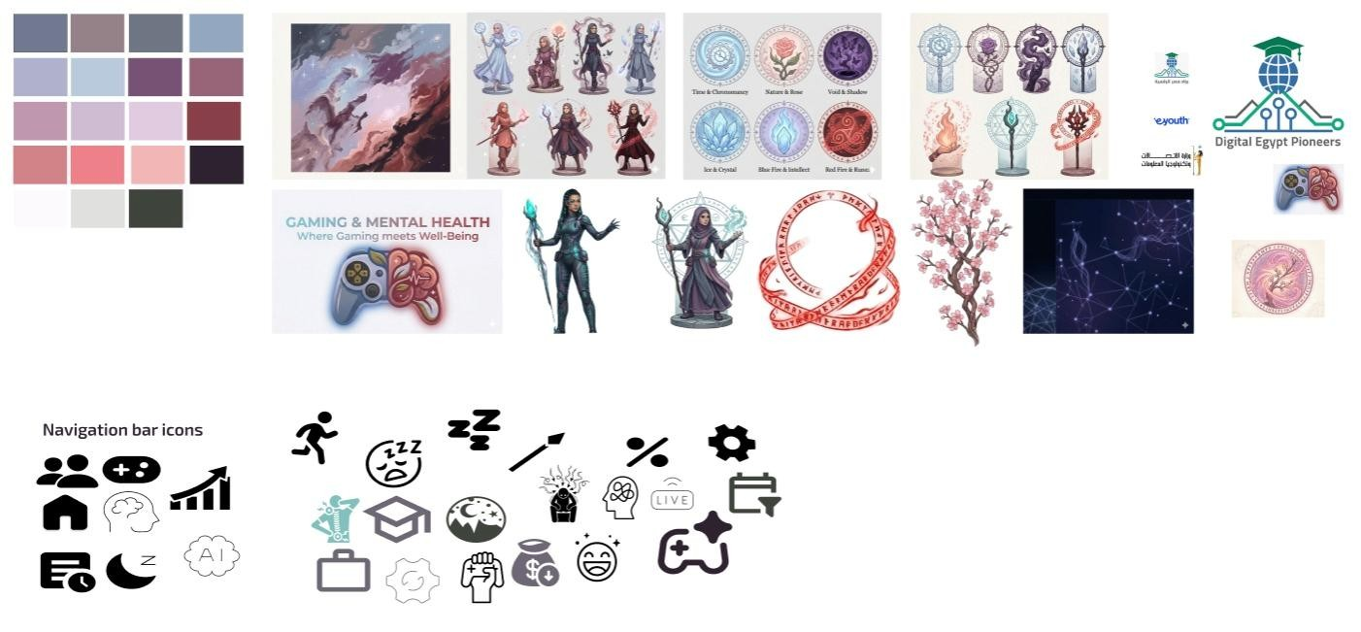
Figma Design:
GM
H
-
fina
l
-
design (Figma
)

5.3.1 Visual Identity & Gaming Theme
The core design philosophy was to deliver rigorous data analysis within an immersive gaming aesthetic — making the insights feel native to the audience being studied. Every visual decision was made in service of this dual goal: analytical clarity and thematic coherence.

Color Palette & Background Design:
A carefully curated color palette was combined with nebula-inspired backgrounds across the main dashboard pages. The cosmic, atmospheric aesthetic was chosen to evoke the immersive worlds gamers inhabit — vast, atmospheric, and visually arresting. The dark nebula textures provide depth and contrast, allowing KPI cards, charts, and annotations to stand out clearly without sacrificing the gaming theme.

Animated Characters & Thematic Icons:
Each dashboard page features an anime-style character illustration, each inspired by a different elemental or archetypal theme that aligns with the page's analytical focus. The characters were chosen to serve as visual anchors that guide the user's attention and reinforce the page's narrative:
- Executive Overview — A mystical warrior character representing the overview of risk and consequence
- Gaming Behavior — A dark fire-wielding character representing intensity and obsession in gaming habits
- Mental Health — A mage character representing mental pressure and the hidden psychological cost of gaming
- Sleep & Physical Health — A crystal mage character representing fragility and the physical toll of screen time
- Productivity & Academic — A nature-themed warrior character representing the battle between gaming and real-world output
- ML Predictions — A cyberpunk/AI-inspired character blending human and technological elements, reflecting the neural network theme

ML Page Design Distinction:
The machine learning predictions page deliberately breaks from the nebula aesthetic. Its background is inspired by AI neural networks — interconnected nodes and data pathways rendered in dark blues and electric teals — creating a visually distinct environment that signals the shift from descriptive analytics to predictive modeling. The character on this page blends a fantasy element with a clear AI/technology inspiration, embodying the fusion of data science and human insight that the ML model represents.

5.4 Dashboard
The following sections present each dashboard page with its full screenshot and a detailed description of the visuals, KPIs, and insights it delivers.

5.4.1 Cover Page — "Where Gaming Meets Well-Being"
The introductory page establishes the project's identity and mission. It displays the project title 'Gaming & Mental Health' prominently alongside the organizational logos (eYouth, Digital Egypt Pioneers, Ministry of Communications), the team name, and a mission statement that frames the analytical purpose:
"Our mission is to decode the digital pulse of a million gamers, turning complex data into the stories that define a balanced and resilient future for play."
A circular icon diagram surrounds a central gaming artifact, representing the six analytical dimensions explored across the dashboard: gaming behavior, mental health, sleep, social interaction, productivity, and physical health. The character — a fully armored warrior — stands as a symbol of resilience and the project's ambition. No KPIs or charts are present; this page serves as the presentation entry point and sets the visual tone for the entire dashboard.

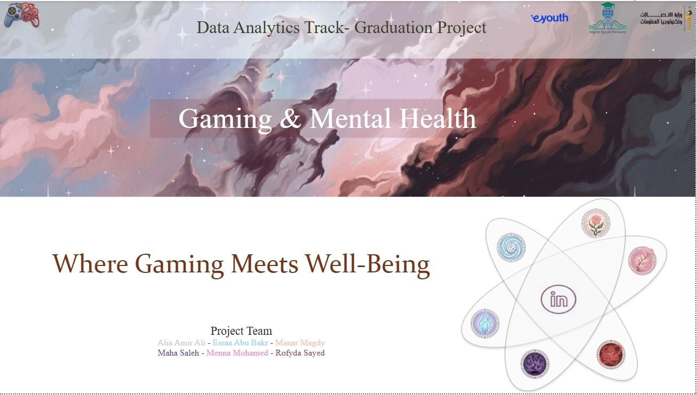
Figure 5.1 — Dashboard Cover Page: Project title slide with mission statement and team branding

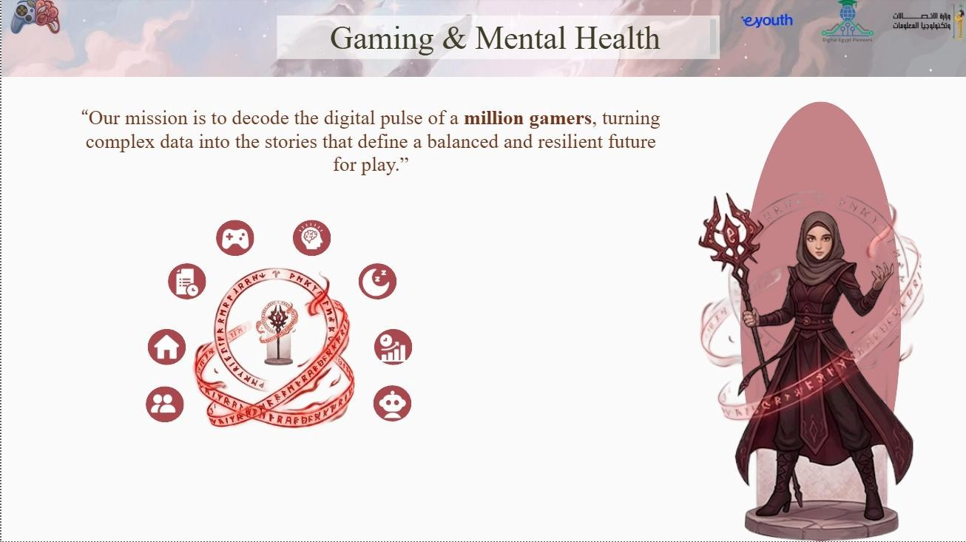
Figure 5.2 — Dashboard Intro Page: Mission statement with thematic icon diagram and warrior character

5.4.2 Page 1 — Executive Overview: "More play, Less sleep, Higher risk"
The Executive Overview page delivers a high-level snapshot of the four most critical headline KPIs alongside demographic and risk breakdown charts. It is designed to give stakeholders an immediate, at-a-glance understanding of the scale of the gaming and mental health relationship across 1 million users.

Element | Type | Key Insight
Avg. Gaming Hours | KPI Card | 4 hrs/day average across 1M users
Mental Risk Index | KPI Card | 20.5 — combined stress, anxiety, depression, loneliness
Gaming Impact Score | KPI Card | 5.3 — composite behavioral impact score
High Risk % | KPI Card | 3.7% of users meet all three high-risk criteria
Mental Risk Breakdown | Donut Chart | 90% Moderate, 10% Low, <1% High risk classification
Stress by Gaming Rank | Bar Chart | Stress ~5.5 across all competitive ranks — minimal variation
Gaming Hours by Demographic | TreeMap | Male and Female users both average 1.92M hrs — near equal
Risk Index by Age | Line Chart | Risk index fluctuates 20.46–20.53 with no strong age trend
Gender / Rank / Age Slicers | Slicers | Dynamic filtering by gender, competitive rank, and age group

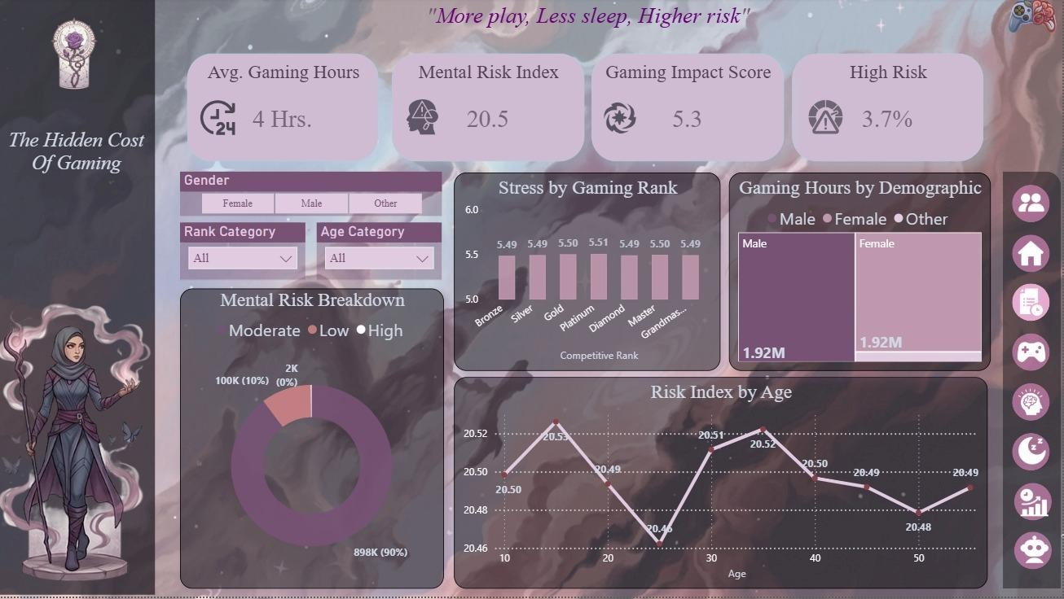
Figure 5.3 — Executive Overview: KPI cards, Mental Risk Breakdown donut, Stress by Rank bar chart, and Risk
Index by Age line chart

5.4.3 Page 2 — Gaming Behavior: "Long sessions dominate — especially at night"
The Gaming Behavior page explores gaming habits, session patterns, and addiction risk across behavioral dimensions. It reveals the distribution of gaming intensity, the relationship between years of gaming and addiction risk, and cross-tabulations of risk levels against daily gaming hours.

Element | Type | Key Insight
Avg. Weekly Sessions | KPI Card | 20 sessions per week on average
High Gaming % | KPI Card | 28.68% of users game more than 5 hrs/day
Night Gamers % | KPI Card | 49.31% of users predominantly game at night
Avg. Streaming Hrs. | KPI Card | 2 hrs/week average streaming consumption
Risk by Daily Hours | Histogram | Risk level rises sharply above 4 hrs/day
Addiction Risk by Tenure | Area Chart | High addiction dominates in users with 10+ years gaming
Addiction by Experience | Stacked Bar | Long-tenure users (10+ yrs) have 0.48M high-addiction users
User Risk Summary | Matrix Table | Cross-tab of addiction level by gaming hour bins across 1M users
Streaming / Balanced Gamer / Violent Ratio Slicers | Slicers | Filter by streaming category, balanced gamer flag, violent game ratio

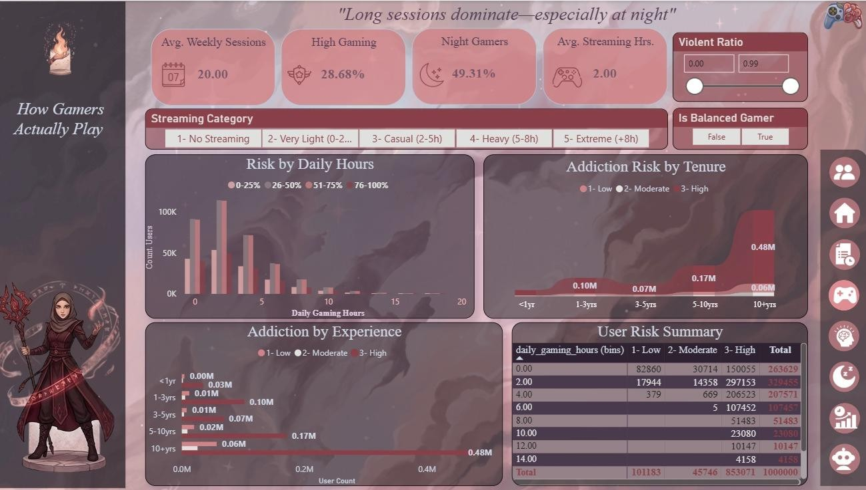
Figure 5.4 — Gaming Behavior: Session KPIs, Risk by Daily Hours histogram, Addiction Risk by Tenure area chart, and User Risk Summary matrix

5.4.4 Page 3 — Mental Health: "Stress and depression levels are consistently elevated"
The Mental Health page examines psychological health outcomes segmented by risk level, social connectivity, and multiplayer behavior. It surfaces the emotional profile of the gaming population — mapping how anxiety, depression, and loneliness vary across risk categories and social play patterns.

Element | Type | Key Insight
Avg. Depression | KPI Card | 5.0/10 — elevated across the population
High Depression % | KPI Card | 21.2% of users score above 7/10 on depression
Happiness Score | KPI Card | 5.98/10 — moderate satisfaction level
Balanced Gamer Score | KPI Card | 7.98 — positive wellness composite
Emotional Indicators | Grouped Bar | High-risk users show 6.50 anxiety vs 3.50 for Low-risk
Social Connectivity | Scatter Plot | Social players (higher multiplayer ratio) show slightly lower loneliness
Happiness Score | Gauge Chart | 5.98 on a 0–10 scale — just below the midpoint
Rank / Loneliness / Social Interaction Slicers | Slicers | Filter by competitive rank, loneliness score range, and social quality

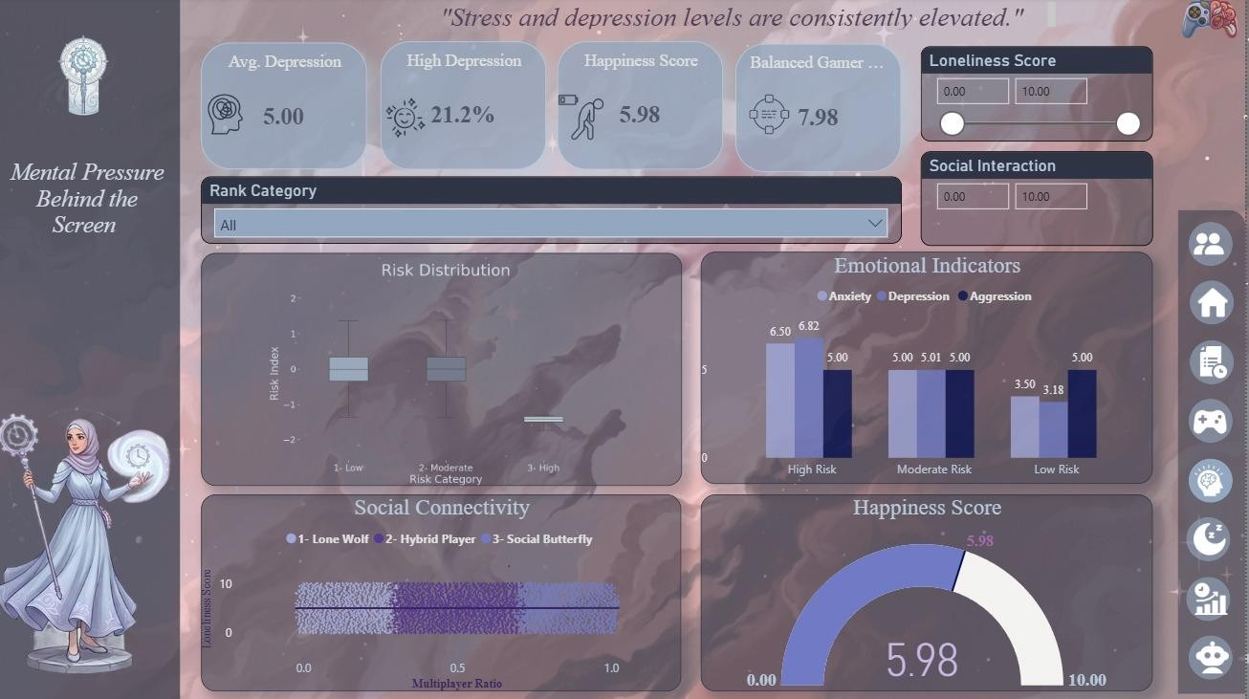
Figure 5.5 — Mental Health: Depression and happiness KPIs, Emotional Indicators grouped bar by risk level,
Social Connectivity scatter, and Happiness gauge

5.4.5 Page 4 — Sleep & Physical Health: "Beyond the Screen: The Body's Breaking Point"
The Sleep & Physical Health page investigates the physical consequences of heavy gaming including sleep deprivation patterns, BMI variation by sleep category, back and eye strain scores, and the relationship between total screen time and sleep quality across risk levels.

Element | Type | Key Insight
Avg. Sleeping Hours | KPI Card | 7 hrs/night average
High Deprivation | KPI Card | 25.14% sleep fewer than 6 hrs/night
Avg. Exercise Hours | KPI Card | 2 hrs/week average exercise
Digital Strain Index | KPI Card | 45% — composite eye + back strain normalized
Sleep Decay | Line Chart | Sleep declines as total screen time increases, especially for High-risk users
BMI Analysis | Bar Chart | Very Short sleepers have highest avg BMI (24.04)
Caffeine Impact | Matrix Table | Caffeine level shows minimal stress variation across headset use
Back Strain | Bar Chart | Back pain scores near 4.0 across all gaming hour groups
Sleeping / Screen Time / Exercise Slicers | Slicers | Filter by sleep category, total screen time range, and exercise frequency

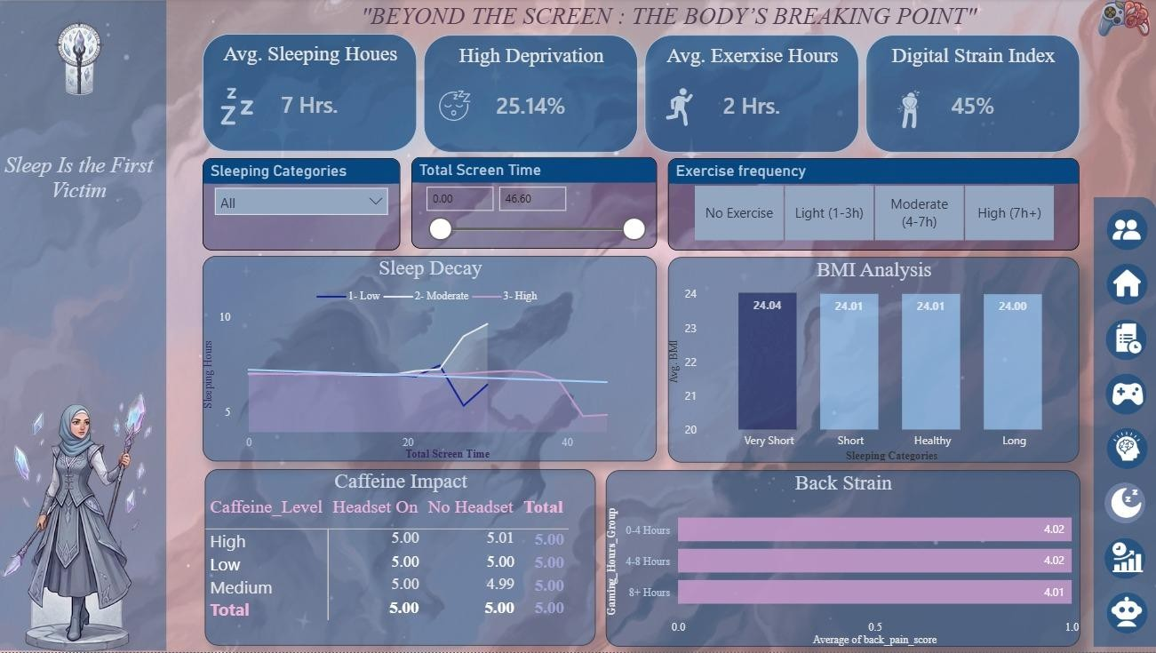
Figure 5.6 — Sleep & Physical Health: Sleep KPIs, Sleep Decay line chart, BMI Analysis by sleep category,
Caffeine Impact matrix, and Back Strain bar chart

5.4.6 Page 5 — Productivity & Academic: "The High Cost of Digital Escape"
The Productivity & Academic page analyses the impact of gaming addiction and behavior on academic performance, work productivity, and socioeconomic outcomes. Despite the high addiction prevalence in the dataset, the page reveals a nuanced finding: addiction level shows surprisingly minimal direct impact on academic and work scores — a consequence of the synthetic data generation, documented transparently.

Element | Type | Key Insight
Academic Performance | KPI Card | 69.86 average score across 1M users
Work Productivity | KPI Card | 69.85 average score
Productivity Risk | KPI Card | 1.32 — composite risk metric
Avg. Income | KPI Card | 77.50K average annual income
Academic Trend | Area Chart | Performance peaks at 4–8 hrs gaming (69.89), dips at 8+ hrs (69.81)
Addiction Impact | Bar Chart | Academic performance nearly flat across addiction tiers — minimal direct impact
Internet Output | Stacked Bar | Internet quality shows no strong productivity differentiation
Social Balance | Donut Chart | 69.29% satisfied with relationships vs 30.71% not satisfied
Income / Work Productivity / Academic Slicers | Slicers | Filter by income range, productivity tier, and academic performance tier

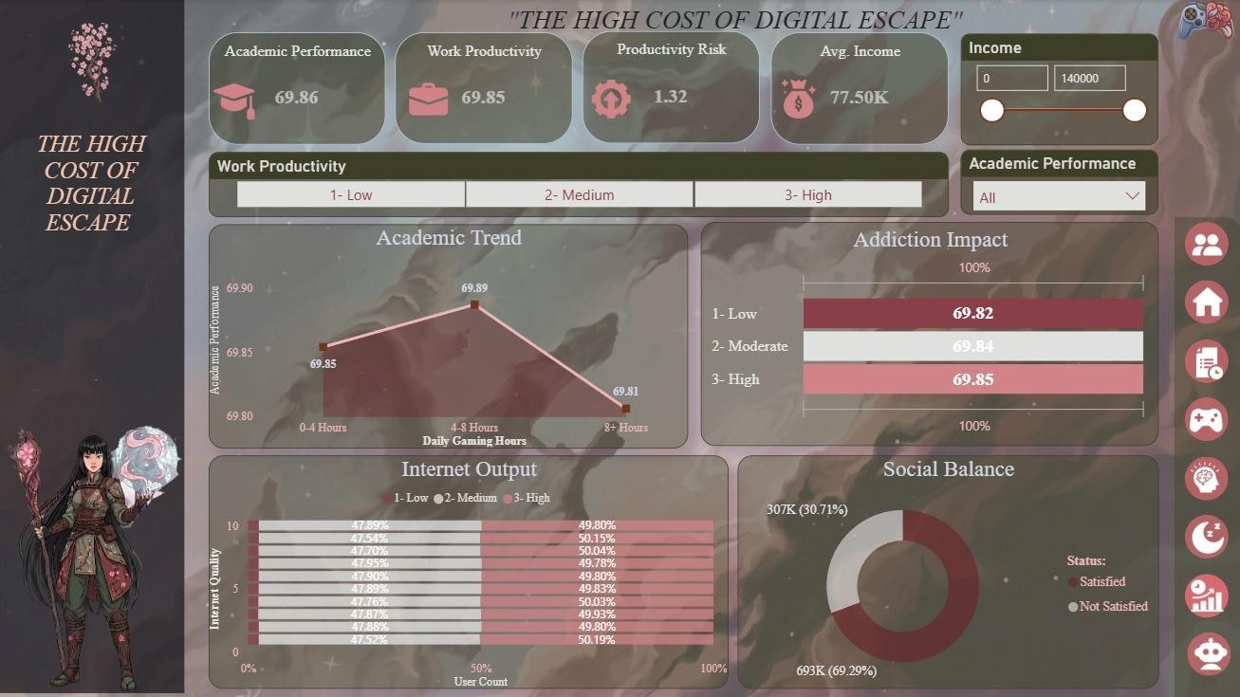
Figure 5.7 — Productivity & Academic: Performance KPIs, Academic Trend area chart, Addiction Impact bar chart, Internet Output stacked bar, and Social Balance donut

5.4.7 Page 6 — ML Predictions: "Addiction Level — Predicted vs Actual"
The ML Predictions page is the dashboard's analytical crown — presenting the output of the XGBoost addiction level regression model (R² = 0.7984) in a fully interactive Power BI visualization. The page allows users to explore how well the model's predictions align with actual addiction scores across 200,000 test users, examine where prediction errors concentrate, and understand error magnitude at different addiction levels.
The page's design deliberately diverges from the nebula aesthetic used across all other pages. The background is rendered as an AI neural network — interconnected glowing nodes and data pathways in deep blue and electric teal — visually signaling the transition from descriptive to predictive analytics. The character is an AI-inspired cyberpunk figure, blending human and technological elements to embody the machine learning model itself.

Element | Type | Key Insight
Avg. Actual Addiction | KPI Card | 2.82 — mean actual addiction level in the 200K test set
Avg. Predicted Addiction | KPI Card | 2.82 — model's mean predicted value; near-perfect average alignment
Mean Absolute Error (MAE) | KPI Card | 0.76 — average prediction error on a 0–10 scale
Prediction Accuracy | Scatter Plot | Predicted vs Actual addiction scatter — strong linear alignment confirms R² = 0.80
Residuals Distribution | Histogram | Errors concentrate between 0–1 (3.38K peak), confirming low typical error; tail extends to 4.0
Avg Absolute Error by Addiction Level | Bar Chart | Error is lowest at extreme addiction levels (0.0: 0.71, 10.0: 0.41) and highest in the middle range (5.0–7.0:  ~0.88–0.89)

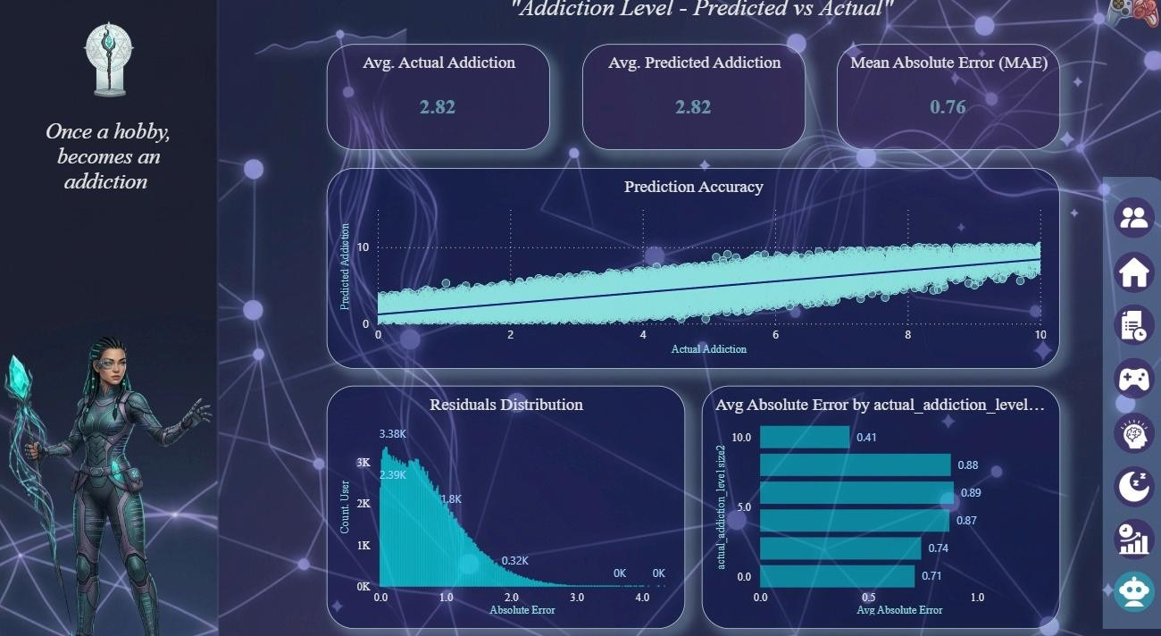
Figure 5.8 — ML Predictions: Actual vs Predicted KPI cards, Prediction Accuracy scatter plot, Residuals
Distribution histogram, and Avg Absolute Error by addiction level bar chart

5.5 Design Summary
The Power BI dashboard represents the convergence of rigorous data engineering, advanced analytics, and intentional design. Every element — from the nebula backgrounds and elemental character illustrations to the DAX-driven KPI cards and interactive slicers — was purposefully chosen to make 1 million rows of gaming and mental health data accessible, engaging, and actionable.

Design Dimension | Choice Made | Rationale
Background Theme (pages 1–  5) | Nebula / cosmic imagery with brand color palette | Evokes immersive gaming worlds; creates visual depth without distracting from data
Background Theme (page 6 — ML) | AI neural network nodes and pathways | Signals transition to predictive analytics; visually distinct from descriptive pages
Character Illustrations | Anime-style elemental warriors, one per page | Each character embodies the page's theme; anchors attention and reinforces narrative
Color Palette | Dark blues, muted purples, and rose tones (pages 1–5); dark blue and electric teal  (page 6) | Consistent gaming aesthetic with sufficient contrast for readability
KPI Cards | Four headline KPIs per page with custom icons | Immediate executive-level insight; scannable at a glance
Design Dimension | Choice Made | Rationale
Interactivity | Multiple slicers per page (demographic, behavioral, range) | Enables deep exploration while maintaining clear default views
Page Count | 6 pages (cover + 5 analytical) | Balances comprehensiveness with navigational clarity

.2 KPI Highlights Across all six dashboard pages, the following headline KPIs are surfaced as card visuals — each representing a critical dimension of the gaming and mental health relationship:

